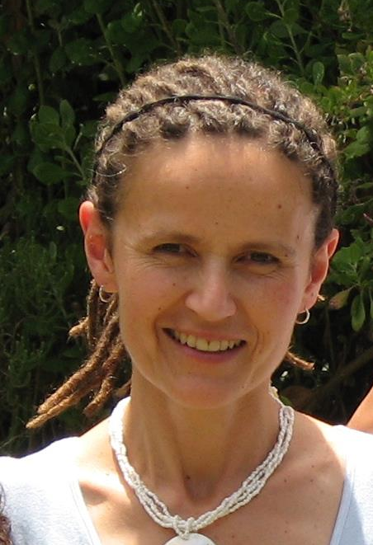

Hi. My name is Karen Quail.

I started the Discipline for Peace workshops in 2004 while I was the school counsellor at Cape Town High. The workshops grew until, at the end of 2005, after 10 years in teaching and counselling, I resigned in order to focus on Discipline for Peace. I have been working independently since then, coaching and running workshops. During this time I also worked for 2 years at Michael Oak Waldorf School as the Nursery Aftercare teacher (for 3 to 6 year olds) This was a big change after 10 years of teenagers, but a wonderful experience. I have had lots of opportunity to observe and work with children of different ages, and the skills I teach are all well tried and tested. The most important part of my training, however, is that I am a parent too. My husband and I have two boys, aged 15 and 19.

Running the workshops has been very meaningful and rewarding work for me. I have been privileged to work with and learn from so many different parents, teachers and other childcare workers. I now offer two other workshops: “Your Child and Temperament” and “Four Temperaments in the Family”. After years of looking at nurture, it is wonderful to look at nature, to look beyond the skills and come to understand the people in the situation. Aside from workshops, I do parent coaching and couple work.

So if you are looking for support or just to increase your knowledge and awareness in these areas, please feel free to contact me about workshops, talks or coaching:

021 6961946, 076 3035324 or email karenquail1@mweb.co.za

(Email is the best because my phone is off when I’m coaching)

